HandOut. 8: Delving into Hive (2%)

# Installation

Access your docker working directory   
Get the git for docker hive : git clone https://github.com/big -data -europe/docker -hive.git   
Execute: docker -compose up –d   
Check all containers : docker ps   
Check your IP : ipconfig /all   
[ToDo: Snapshot of Presto at 8080] (Presto is part of Hive)

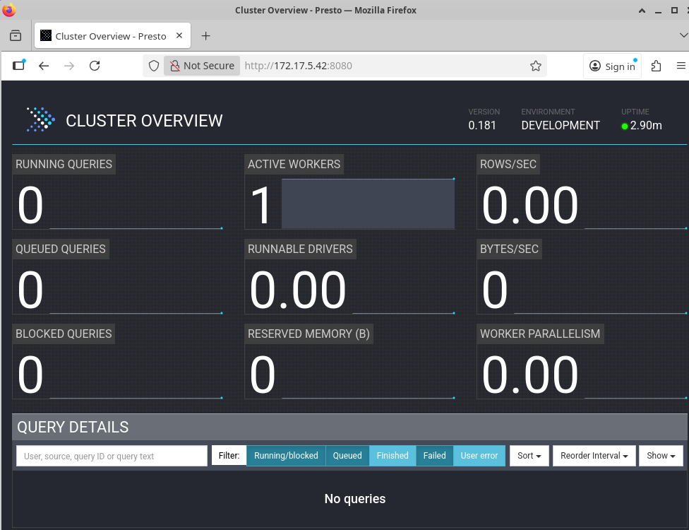  
Bash into hive : docker -compose exec hive -server bash   
Execute Beeline : /opt/hive/bin/beeline -u jdbc:hive2://localhost:10000   
   
Basics   
Check Beeline help for all available commands: !help   
List all current connections: !list   
Set variables in Beeline for session -specific configurations: !set [ToDo: Try setting 2   
variables and check their output]

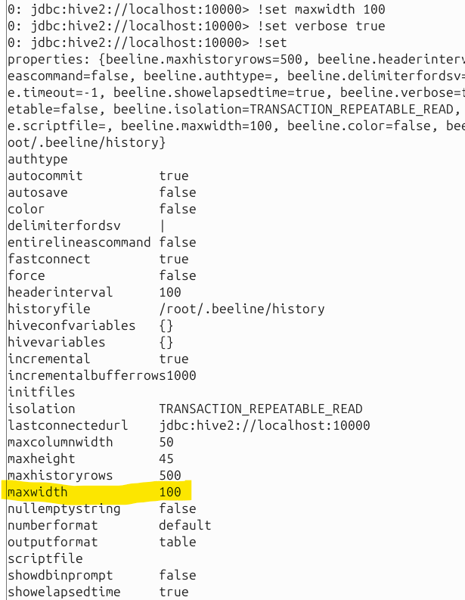

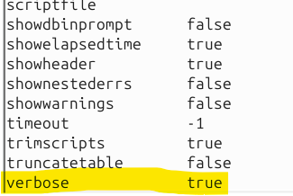  
Modify how query results are displayed: !set outputformat=<format> (replace format by   
“table”, “vertical”, “csv” )   
Quit the session : !quit   
Login again into Beehive   
   
Create Database:   
CREATE DATABASE [IF NOT EXISTS] userdb;   
CREATE SCHEMA userdb;   
SHOW DATABASES;   
 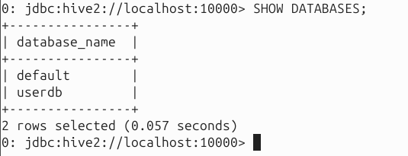

Drop Database:   
DROP DATABASE IF EXISTS userdb;   
DROP DATABASE IF EXISTS userdb CASCADE; //drop tables then database   
DROP SCHEMA userdb;   
SHOW DATABASES;

Create Table:   
CREATE TABLE IF NOT EXISTS employee ( eid int, name String, salary String, destination   
String)   
COMMENT ‘Employee details’   
ROW FORMAT DELIMITED   
FIELDS TERMINATED BY ‘ \t’   
LINES TERMINATED BY ‘ \n’   
STORED AS TEXTFILE;   
 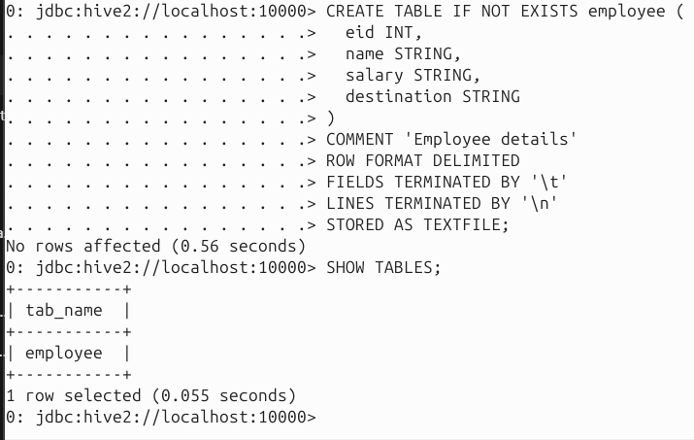  
Alter Table:   
ALTER TABLE name RENAME TO new_name   
ALTER TABLE name ADD COLUMNS (col_spec[, col_spec ...])

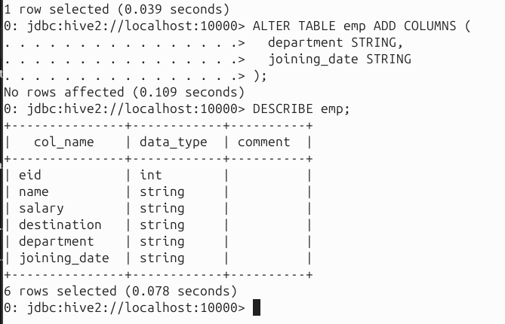  
ALTER TABLE name DROP [COLUMN] column_name   
ALTER TABLE name CHANGE column_name new_name new_type ALTER TABLE name   
REPLACE COLUMNS (col_spec[, col_spec ...])   
ALTER TABLE employee RENAME TO emp;

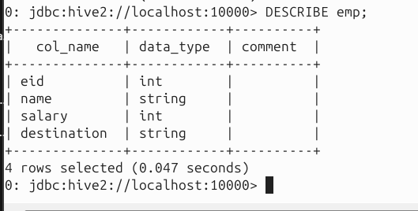  
   
Drop Table   
DROP TABLE IF EXISTS employee;

Exercise s with S tudent DB :   
DDL:   
• CREATE DATABASE IF NOT EXISTS student_db;   
• USE student_db;   
• SHOW DATABASES;   
• DROP DATABASE IF EXISTS student_db CASCADE;   
   
• CREATE TABLE students (   
 student_id INT,   
 name STRING,   
 age INT,   
 major STRING   
)   
ROW FORMAT DELIMITED   
FIELDS TERMINATED BY ','   
STORED AS TEXTFILE;   
• SHOW TABLES;   
• DESCRIBE students;

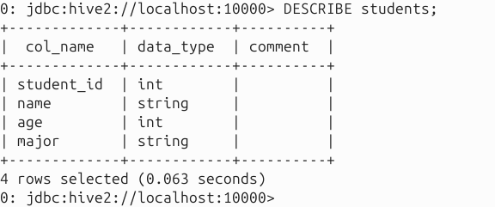  
• ALTER TABLE students ADD COLUMNS (gpa FLOAT);   
• ALTER TABLE students RENAME TO student_info;   
• DROP TABLE IF EXISTS student_info;   
DDL:   
• [ToDo : Create a CSV file with some fictitious student data – should have column   
names at top and data below , e.g., name, CGPA, degree program etc. ]

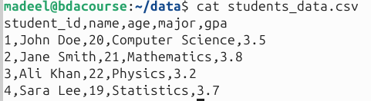  
• Load student CSV [ToDo: paste output] : LOAD DATA LOCAL INPATH   
'/path/to/students_data.csv' INTO TABLE students;

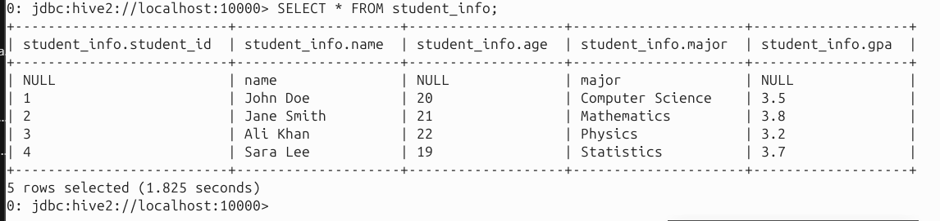  
• [ToDo: Modify the data in the CSV file]   
• Replace existing data in the table [ToDo: paste output] : LOAD DATA LOCAL INPATH   
'/path/to/students_data.csv' OVERWRITE INTO TABLE students;

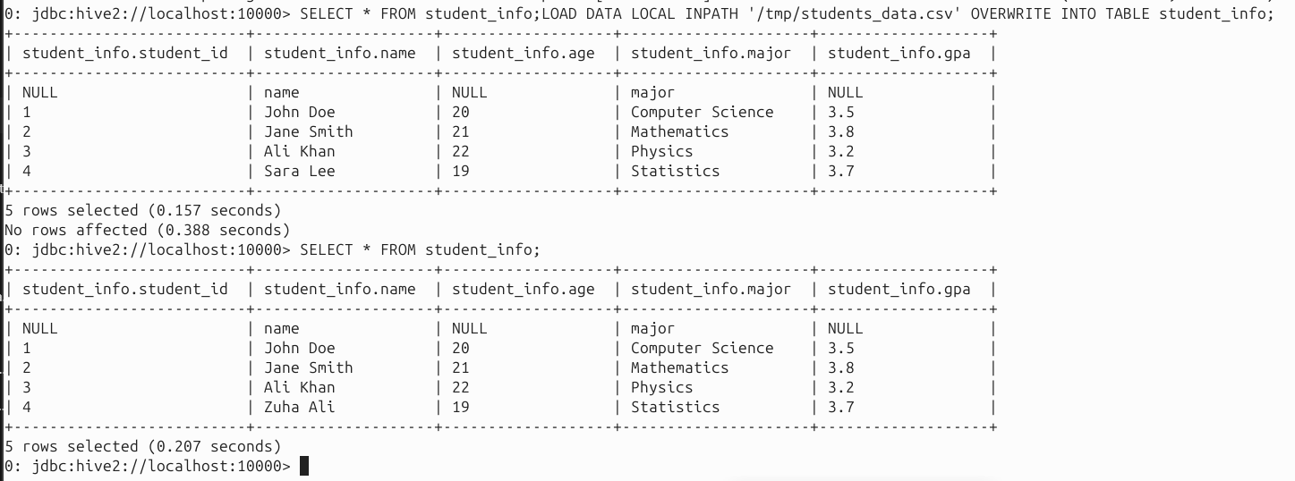

• Inserting data – this should add data after your CSV data [ToDo: paste output] :   
INSERT INTO TABLE students VALUES (1, 'John Doe', 20, 'Computer Science', 3.5);

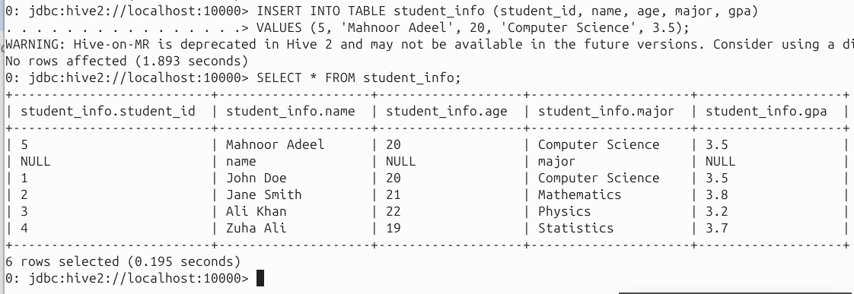   
• Insert data from another table – you need to create another table for this – try for your   
own knowledge [ToDo: paste output] : INSERT INTO TABLE students SELECT * FROM   
student_backup;

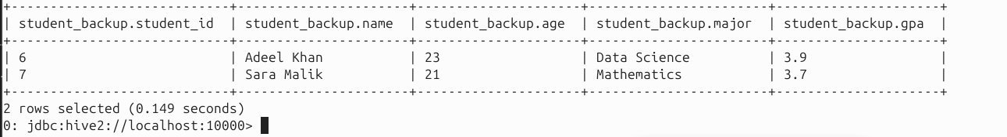

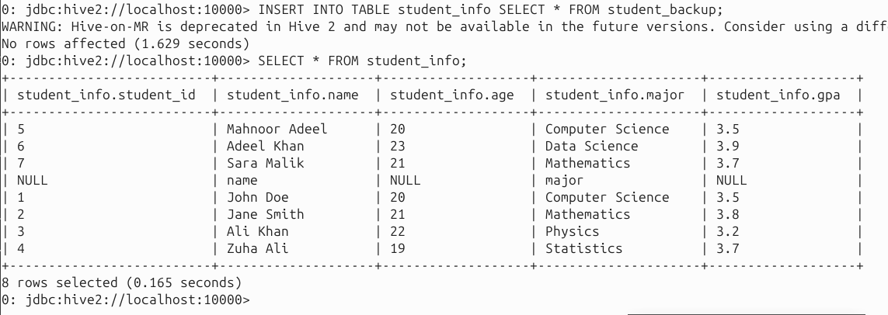  
• Update GPA: UPDATE students SET gpa = 3.8 WHERE student_id = 1;   
• DELETE FROM students WHERE age < 18;   
   
Queries:   
• SELECT * FROM students;   
• SELECT * FROM students WHERE major = 'Computer Science';

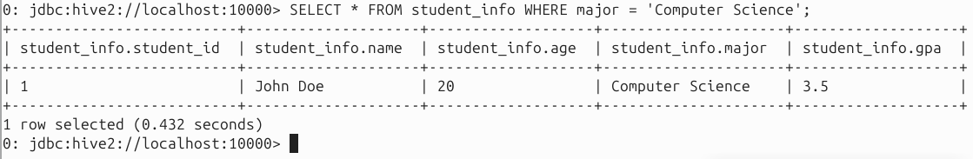  
• SELECT * FROM students ORDER BY gpa DESC;

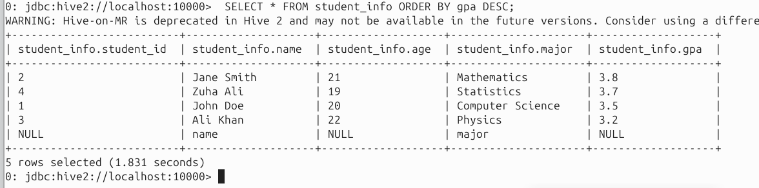  
• SELECT major, COUNT(*) AS student_count FROM students GROUP BY major;

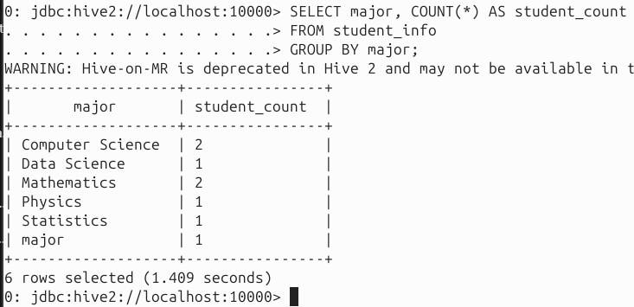  
• [ToDo: paste output – you need to create a departments table first and then fill it up   
with some dummy data] SELECT s.student_id, s.name, d.department_name   
FROM students s   
JOIN departments d ON s.major = d.major;

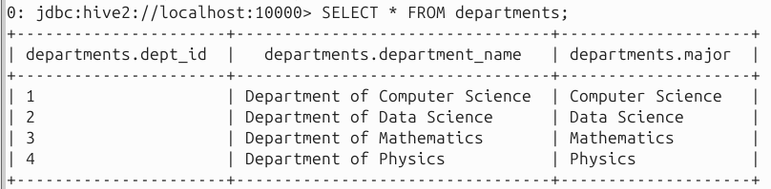

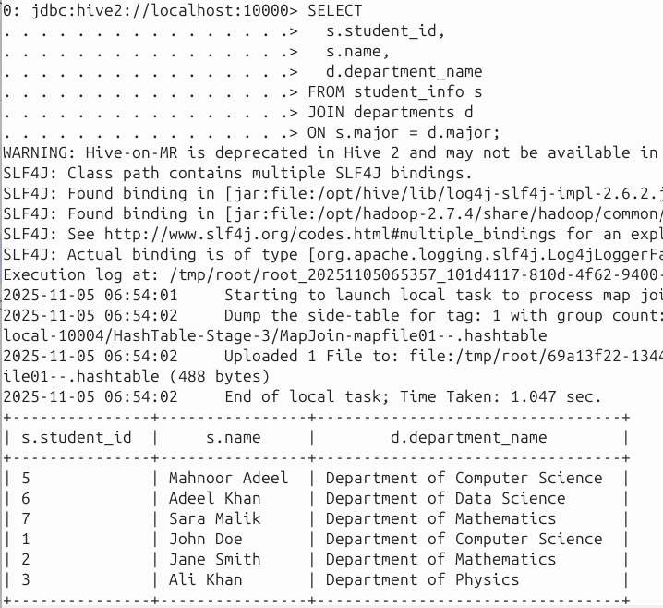  
Partition and Bucket:   
Suppose that a table named Tab1 contains employee data such as id, name, dept, and yoj   
(i.e., year of joining). Suppose you need to retrieve the details of all employees who joined in   
2012. A query searches the whole table for the required information. However, if you   
partition the employee data with the year and store it in a separate file, it reduces the query   
processing time. The following example shows how to partition a file and its data:   
The following file contains employeedata table.   
Path: /tab1/employeedata/file1   
id, name, dept, yoj   
1, gopal, TP, 2012   
2, kiran, HR, 2012   
3, kaleel,SC, 2013   
4, Prasanth, SC, 2013

The above data is partitioned into two files using year.   
Path: /tab1/employeedata/2012/file2   
1, gopal, TP, 2012   
2, kiran, HR, 2012   
   
Path: /tab1/employeedata/2013/file3   
3, kaleel,SC, 2013   
4, Prasanth, SC, 2013   
[ToDo: paste output – you can create a partition of your own choice] Partition by year of   
enrollment:   
CREATE TABLE students_by_year (   
 student_id INT,   
 name STRING,   
 age INT,   
 major STRING   
)   
PARTITIONED BY (year INT)   
STORED AS TEXTFILE;

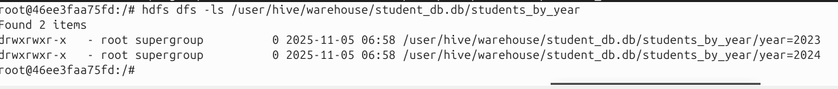

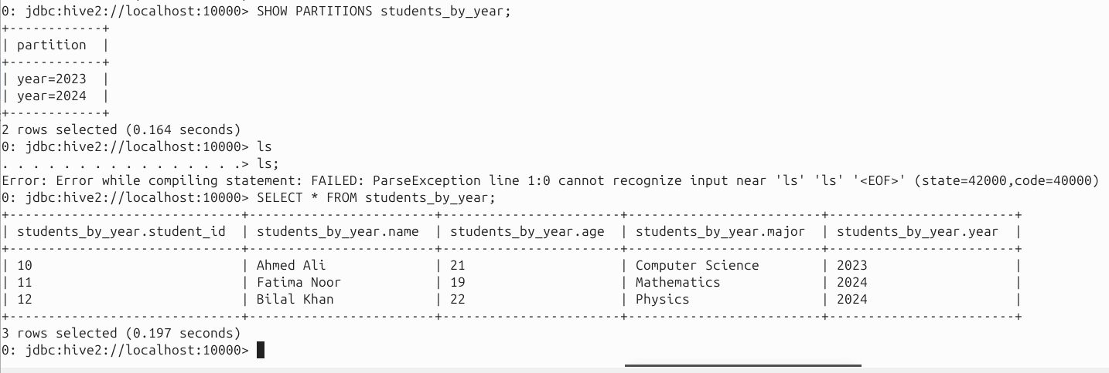  
   
[ToDo: paste output – you can create clusters/buckets of your own choice] Clustered by   
student_id into 4 buckets:   
CREATE TABLE students_bucketed (   
 student_id INT,   
 name STRING,   
 age INT,   
 major STRING

)   
CLUSTERED BY (student_id) INTO 4 BUCKETS   
STORED AS TEXTFILE;

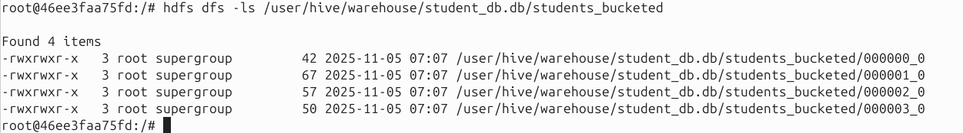

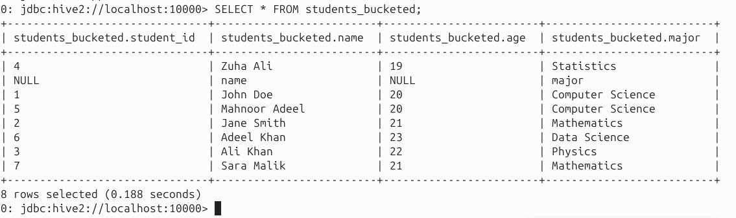  
   
[ToDo : paste output – you can explain plan of any query of your own choice – describe the   
output] Explain the query plan:   
EXPLAIN SELECT * FROM students WHERE age > 20;

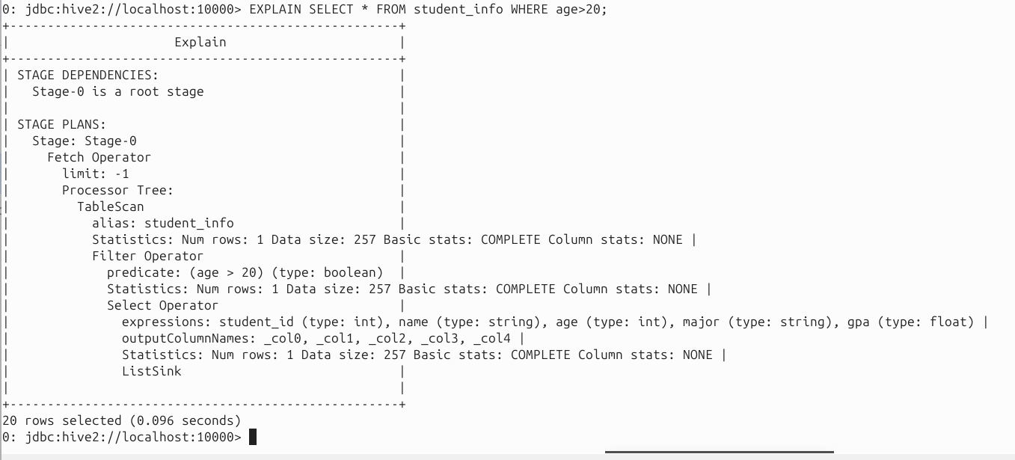  
Built -in Functions:   
round, floor, ceil, rand, concat, substr, upper, ucase , lower, lcase, trim, rtrim, regex_replace,   
size, cast, to_date, year, month, day, get_json_object   
[ToDo: try 2 functions and paste output]

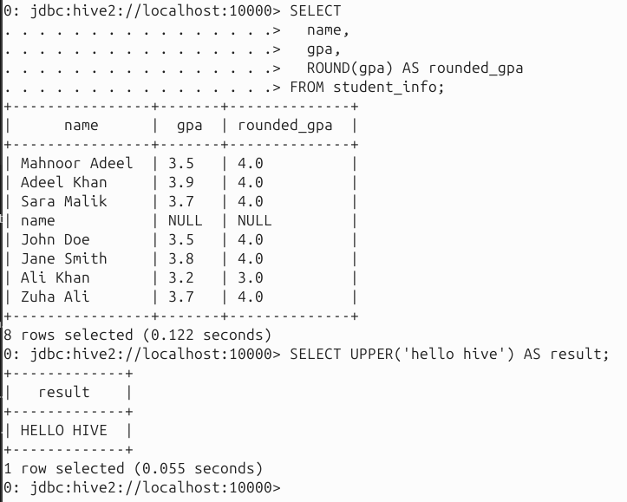  
Aggregate Functions:   
count(*), count(expr), sum, avg, min, max

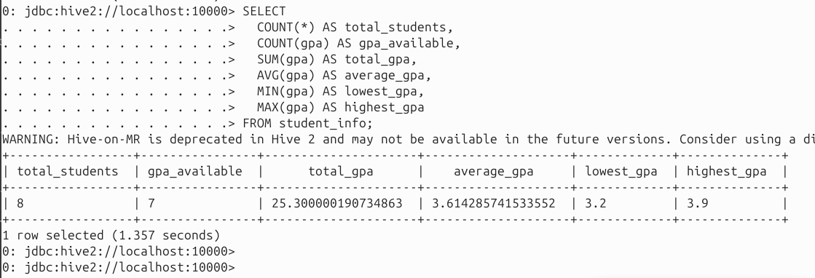  
Views:   
The usage of view in Hive is same as that of the view in SQL. It is a standard RDBMS concept.   
We can execute all DML operations on a view .   
Example: CREATE VIEW emp_30000 AS SELECT * FROM employee WHERE salary>30000;   
[ToDo: create a view on the student’s database and show output]

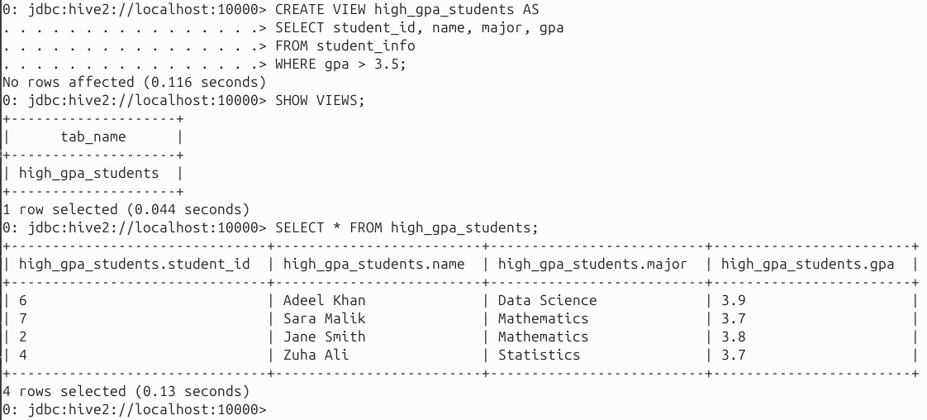  
Indexes   
CREATE INDEX inedx_salary ON TABLE employee(salary) AS   
'org.apache.hadoop.hive.ql.index.compact.CompactIndexHandler';   
[ToDo: create an index on the student’s database and execute queries to show difference in   
performance after indexing]

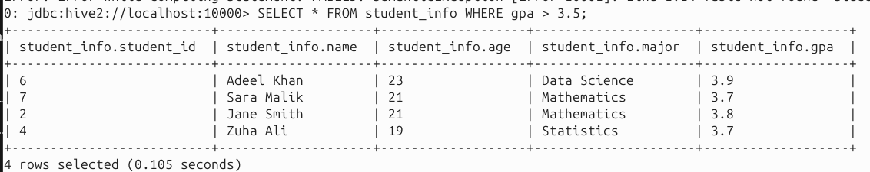

  
Joins:   
Some basic examples are given below.   
   
Inner Join   
SELECT c.ID, c.NAME, c.AGE, o.AMOUNT FROM CUSTOMERS c JOIN ORDERS o ON (c.ID =   
o.CUSTOMER_ID);

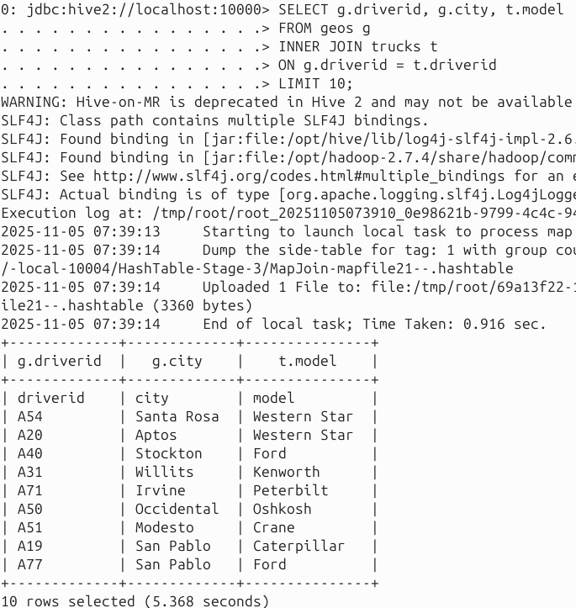  
   
Left Outer Join   
SELECT c.ID, c.NAME, o.AMOUNT, o.DATE FROM CUSTOMERS c LEFT OUTER JOIN ORDERS   
o ON (c.ID = o.CUSTOMER_ID);   
   
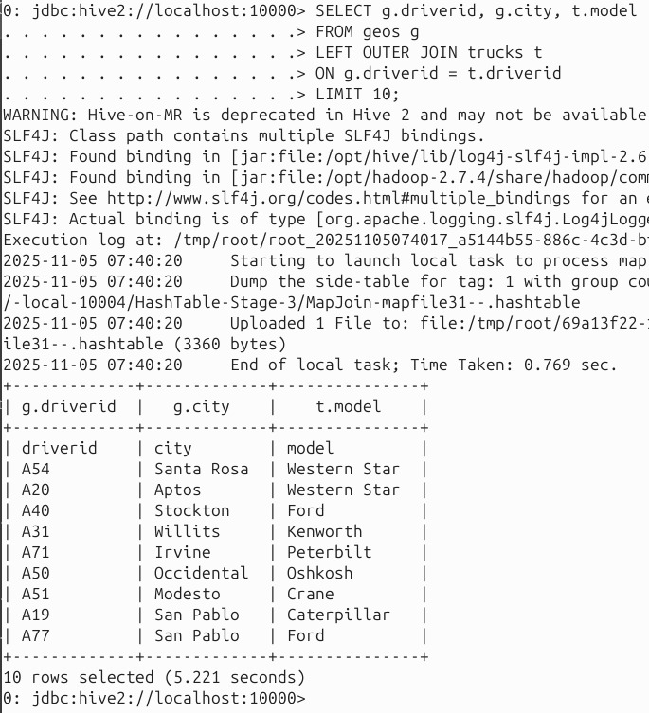

Right Outer Join   
SELECT c.ID, c.NAME, o.AMOUNT, o.DATE FROM CUSTOMERS c RIGHT OUTER JOIN   
ORDERS o ON (c.ID = o.CUSTOMER_ID);

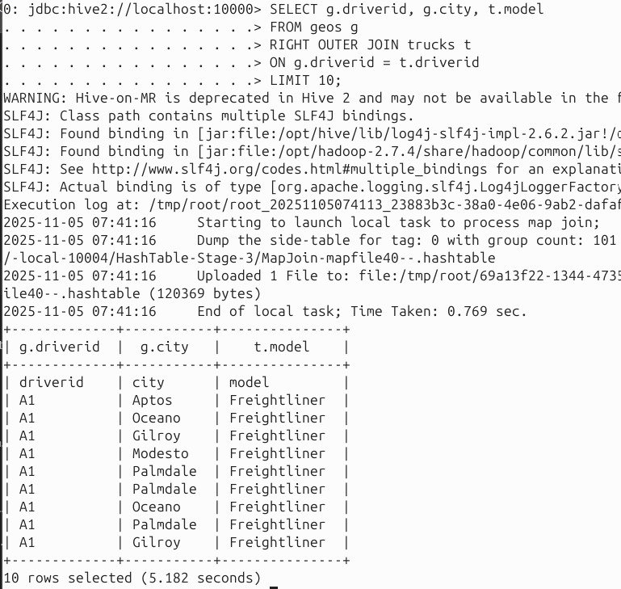  
   
Full Outer Join:   
SELECT c.ID, c.NAME, o.AMOUNT, o.DATE FROM CUSTOMERS c FULL OUTER JOIN ORDERS   
o ON (c.ID = o.CUSTOMER_ID);

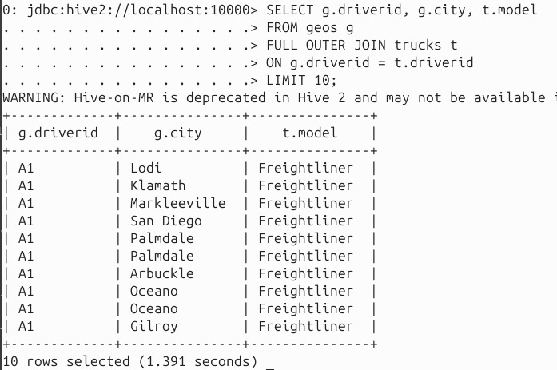  
   
Experiment with geolocation file :   
Make directories for data files in container (geolocation data, available as geolocation.csv)   
docker -compose exec hive -server bash   
cd ..   
whereis hive   
cd home   
mkdir geolocationmkdir trucks   
exit

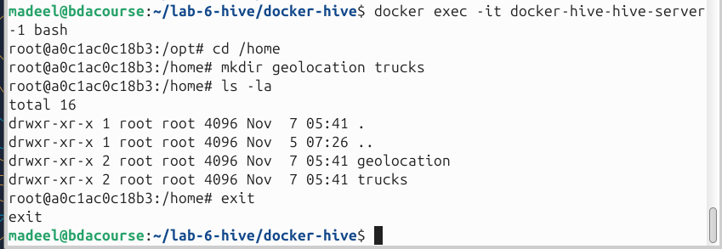

Copy from local to container   
Access hive folder (where yml file is located)   
docker cp geolocations.csv docker -hive -master_hive -server_1:/home/geolocation   
docker -compose exec hive -server bash   
check the copied file   
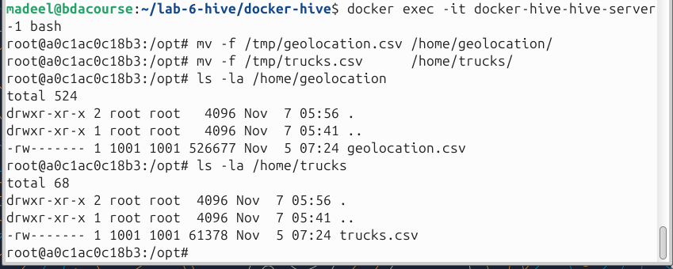  
Copy from container to hdfs   
hadoop fs -mkdir /user/data/   
hadoop fs -put -f /home/geolocation /user/data/   
hadoop fs -ls /user/data/geolocation

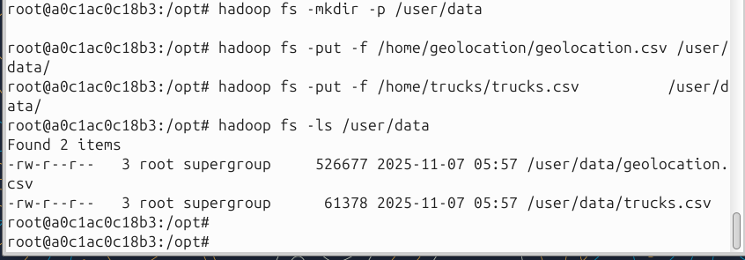  
   
Access hive command prompt   
/opt/hive/bin/beeline -u jdbc:hive2://localhost:10000   
   
First, we need to create the table according to the schema of geolocation.csv   
CREATE TABLE IF NOT EXISTS geos   
(   
truckid string,   
driverid string,   
event string,   
latitude decimal(5,0),   
longitude decimal(5,0),   
city string,   
state string,   
velocity int,

event_ind int,   
idling_ind int   
)   
COMMENT 'Geo Table' ROW FORMAT DELIMITED FIELDS TERMINATED BY ',';   
   
LOAD DATA INPATH '/user/data/geolocation/geolocation.csv' INTO TABLE geos;

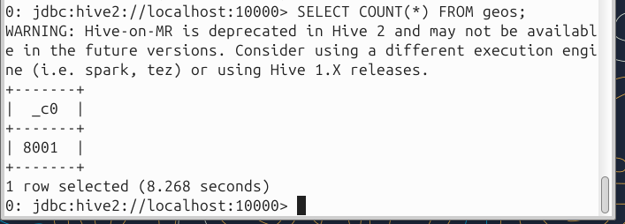   
Now, run the following queries:   
• select * from geos;

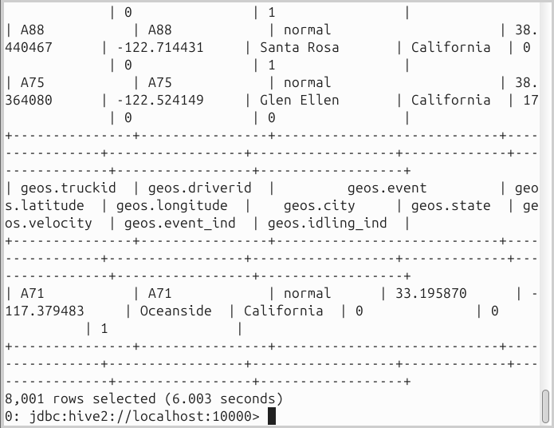  
• select * from geos where event = "overspeed";

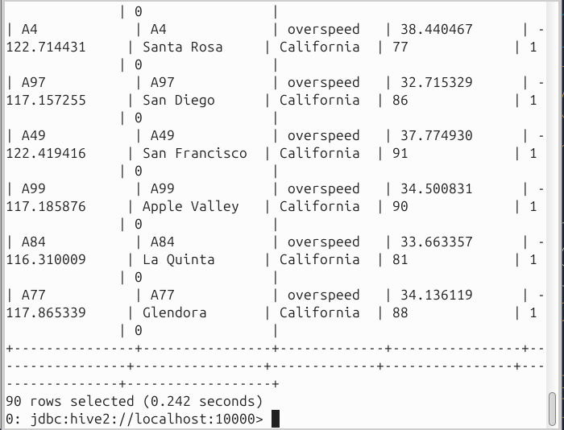  
• select * from geos where velocity < 40;

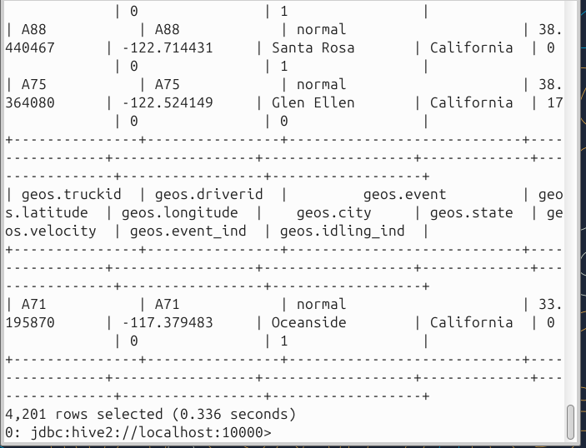  
• select distinct event from geos;

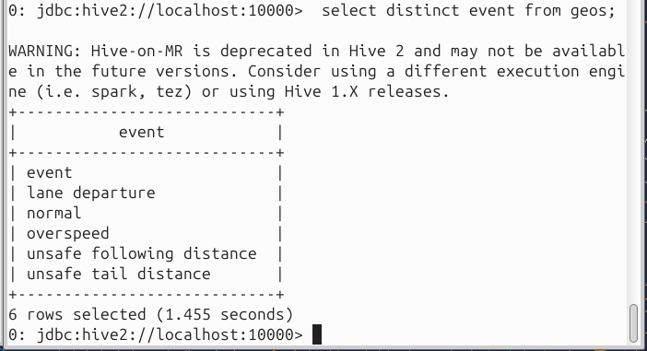  
• select avg(velocity) from geos where event ="lane departure" group by event;

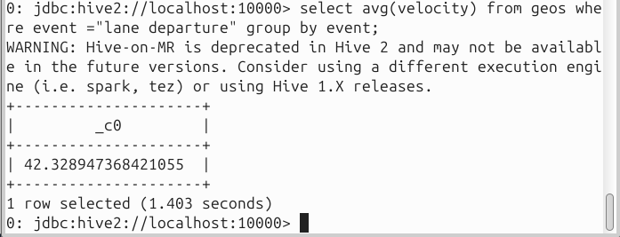  
• select * from geos order by velocity desc limit 5;   
 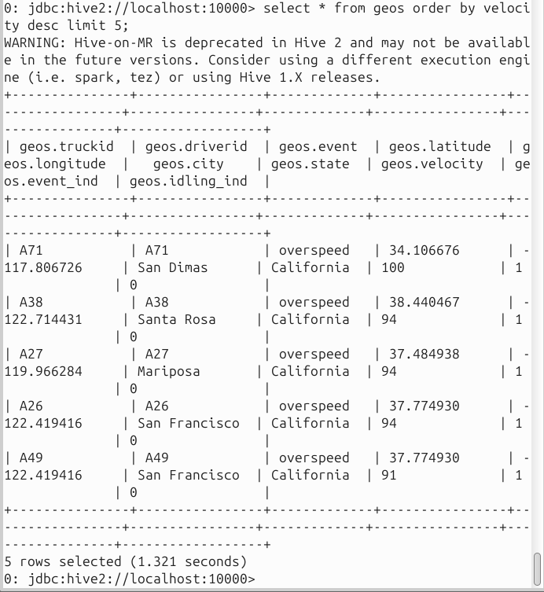  
[ToDo: Show queries and their output]   
Exercises   
• Get all the cities for driver id A54   
• Get driver who have visited the least amount of cities   
• Get driver who on average drives the slowest   
• Using the like statement get all cities with name starting from A

# Importing trucks file

We need to import the trucks data file now.   
Make a “trucks” directory, copy from local to container, copy from container to hdfs, and   
access hive command prompt (as for the above ge olocation file)   
CREATE EXTERNAL TABLE IF NOT EXISTS trucks (driverid STRING,truckid STRING,model   
STRING,jun13_miles INT,jun13_gas INT,may13_miles INT,may13_gas INT,apr13_miles   
INT,apr13_gas INT,mar13_miles INT,mar13_gas INT,feb13_miles INT,feb13_gas   
INT,jan13_miles INT,jan13_gas INT,dec12_miles INT,dec12_gas INT,nov12_miles   
INT,nov12_gas INT,oct12_miles INT,oct12_gas INT,sep12_miles INT,sep12_gas

INT,aug12_miles INT,aug12_gas INT,jul12_miles INT,jul12_gas INT,jun12_miles   
INT,jun12_gas INT,may12_miles INT,may12_gas INT,apr12_miles INT,apr12_gas   
INT,mar12_miles INT,mar12_gas INT,feb12_miles INT,feb12_gas INT,jan12_miles   
INT,jan12_gas INT,dec11_miles INT,dec11_gas INT,nov11_miles INT,nov11_gas   
INT,oct11_miles INT,oct11_gas INT,sep11_miles INT,sep11_gas INT,aug11_miles   
INT,aug11_gas INT,jul11_miles INT,jul11_gas INT,jun11_miles INT,jun11_gas   
INT,may11_miles INT,may11_gas INT,apr11_miles INT,apr11_gas INT,mar11_miles   
INT,mar11_gas INT,feb11_miles INT,feb11_gas INT,jan11_miles INT,jan11_gas   
INT,dec10_miles INT,dec10_gas INT,nov10_miles INT,nov10_gas INT,oct10_miles   
INT,oct10_gas INT,sep10_miles INT,sep10_gas INT,aug10_miles INT,aug10_gas   
INT,jul10_miles INT,jul10_gas INT,jun10_miles INT,jun10_gas INT,may10_miles   
INT,may10_gas INT,apr10_miles INT,apr10_gas INT,mar10_miles INT,mar10_gas   
INT,feb10_miles INT,feb10_gas INT,jan10_miles INT,jan10_gas INT,dec09_miles   
INT,dec09_gas INT,nov09_miles INT,nov09_gas INT, oct09_miles INT,oct09_gas   
INT,sep09_miles INT,sep09_gas INT,aug09_miles INT,aug09_gas INT,jul09_miles   
INT,jul09_gas INT,jun09_miles INT,jun09_gas INT,may09_miles INT,may09_gas   
INT,apr09_miles INT,apr09_gas INT,mar09_miles INT,mar09_gas INT,feb09_miles   
INT, feb09_gas INT,jan09_miles INT,jan09_gas INT) ROW FORMAT DELIMITED FIELDS   
TERMINATED BY ',' STORED AS TEXTFILE LOCATION '/user/data/trucks.csv';

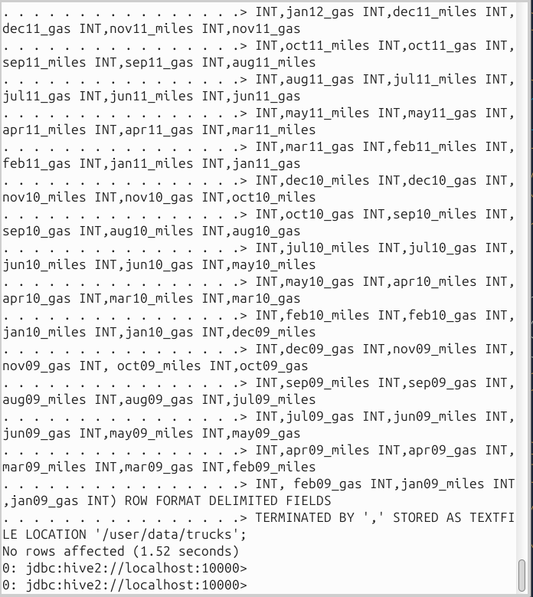  
[ToDo: Show output of above – what advantage do we have for an external table]

When we drop an EXTERNAL table, Hive deletes only the table metadata but keeps the actual data files in HDFS intact.

This means the data is not lost and the table can be recreated later using the same LOCATION.

| **Managed Table (default)** | **External Table** |
| --- | --- |
| Dropping the table deletes the data from HDFS | Dropping the table keeps the data in HDFS |
| Hive owns the data | Hive only references the data |
| Good for temporary/derived data | Good for shared data / data ingestion |

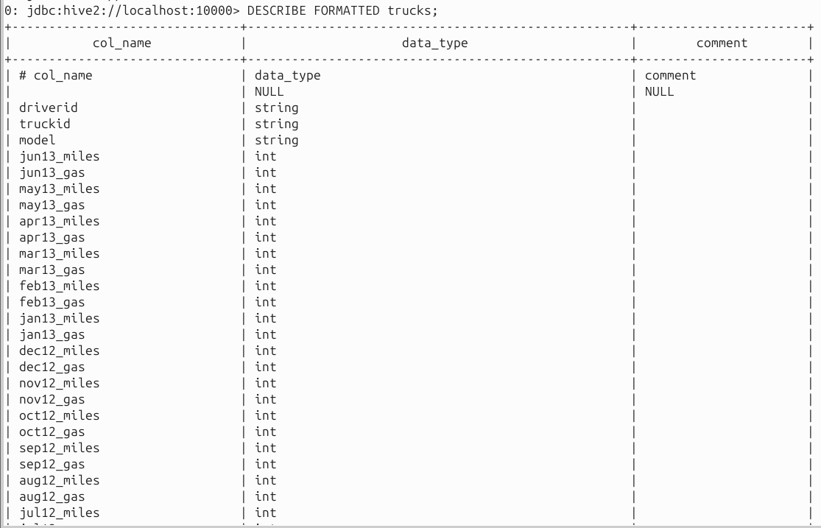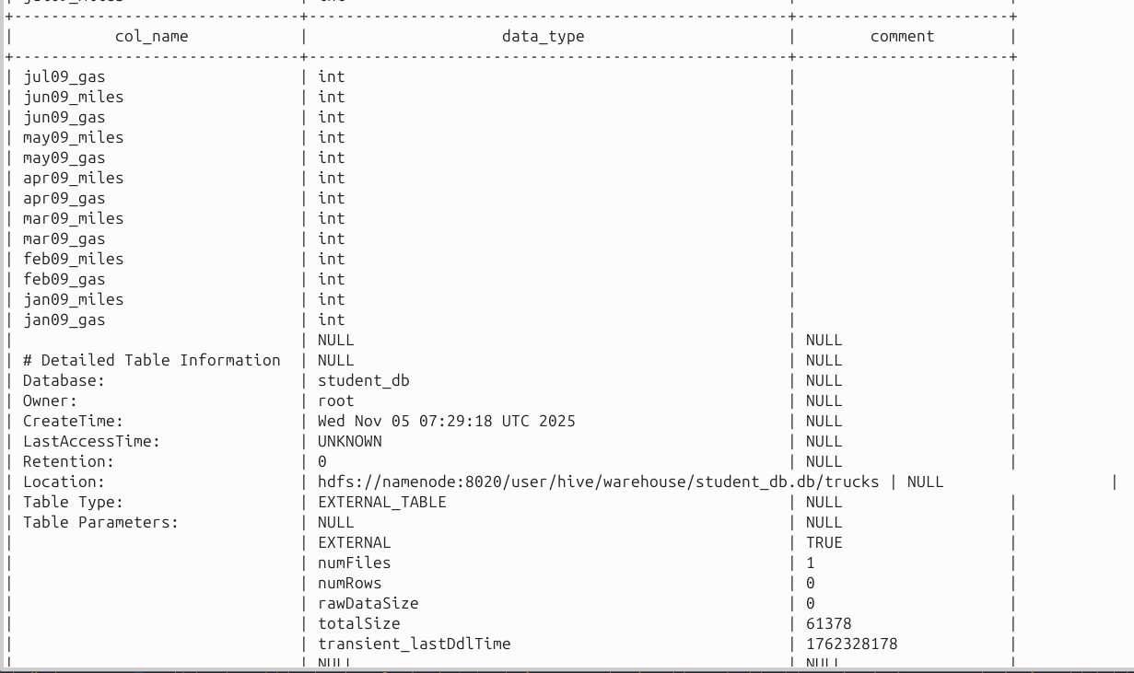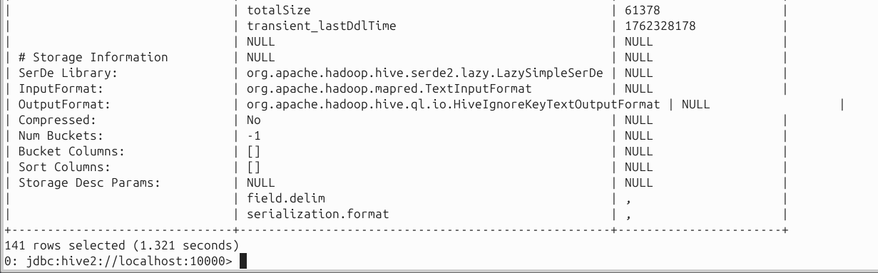

## [ToDo: What is each query doing – explain in a single sentence only in your own words:]

• select count(model) as modelCount, model from trucks group by model order by   
modelCount desc;

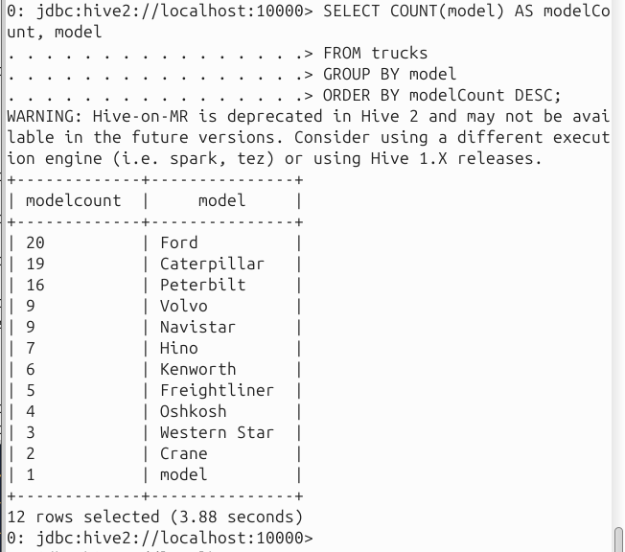

Counts how many trucks there are of each model and shows the model with the highest count first.  
• select * from geos ORDER BY truckid;

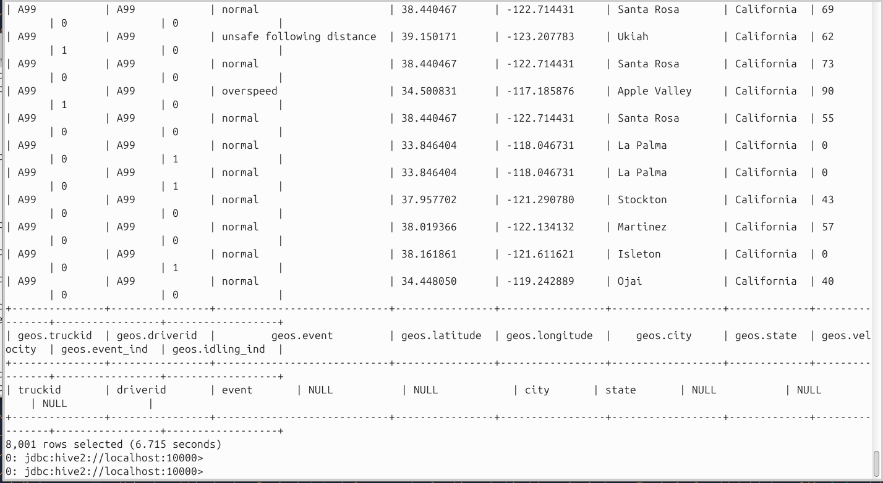

Globally sorts the whole geos table by truckid using a single reducer (total order).  
• select * from geos SORT BY driverid ASC;

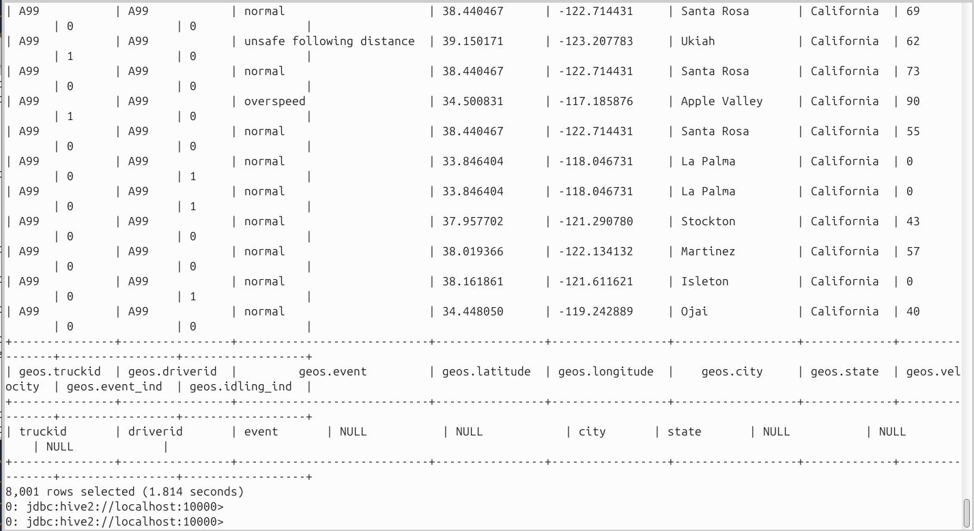

Sorts rows by driverid within each reducer (not a global total order).  
• select driverid, city from geos DISTRIBUTE BY driverid; (what is distribute by and its   
advantage?)

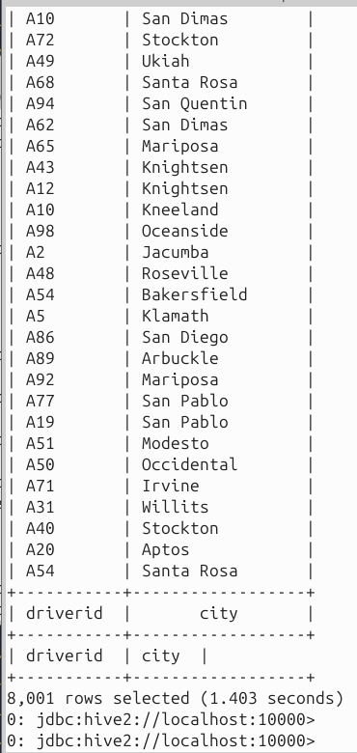

Sends rows with the same driverid to the same reducer (good for parallel grouping/joins); advantage: reduces data shuffling for same-key work.  
• select driverid, city from geos CLUSTER BY driverid; (what is cluster by and its   
advantage?)

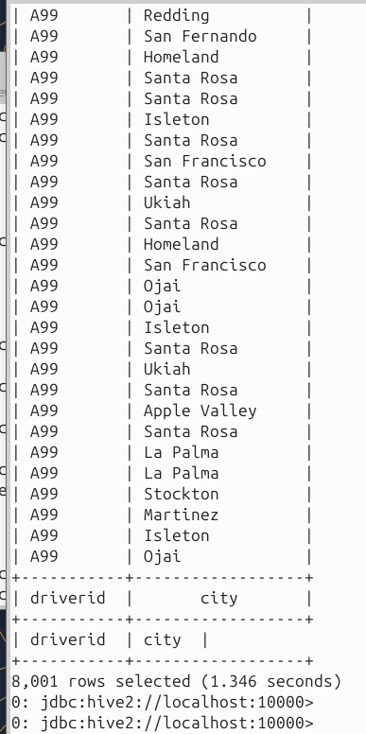

Combination of DISTRIBUTE BY driverid and SORT BY driverid in one step; advantage: same keys land together and are sorted, which speeds downstream processing.  
• UPDATE geolocation SET driverid = null WHERE event = “normal”;

docker Hive uses **TEXTFILE non-transactional** tables, so UPDATE/MERGE won’t execute. So thats why we will use INSERT OVERWRITE

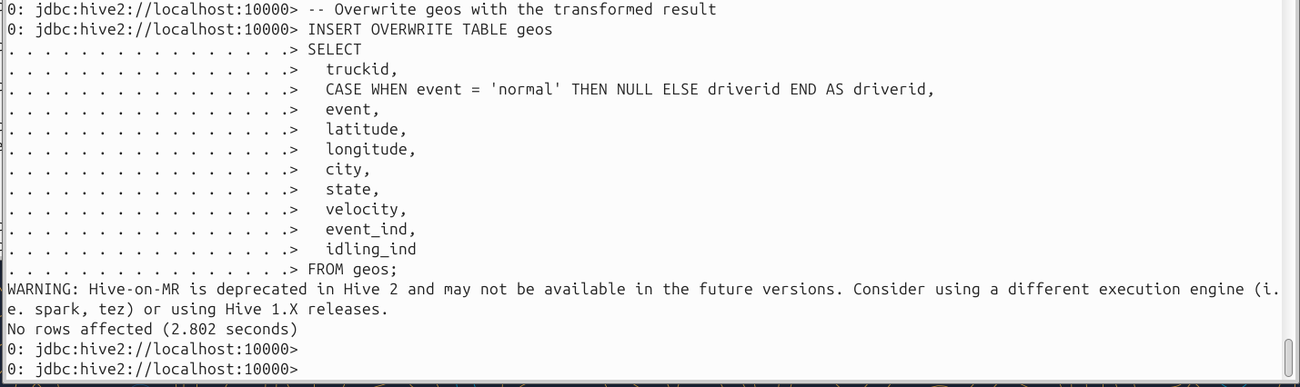

Rewrites the geos table so any row with event='normal' gets driverid set to NULL.  
• MERGE INTO geos USING   
(SELECT * FROM trucks) sub ON sub.driverid=geos.driverid   
WHEN MATCHED THEN UPDATE SET truckid = sub.truckid, driverid = sub.driverid   
WHEN NOT MATCHED THEN INSERT VALUES (sub.truckid, sub.driverid);

Our Hive (2.3, TEXTFILE) is non-ACID, so we used the portable INSERT OVERWRITE approach which is the standard workaround.

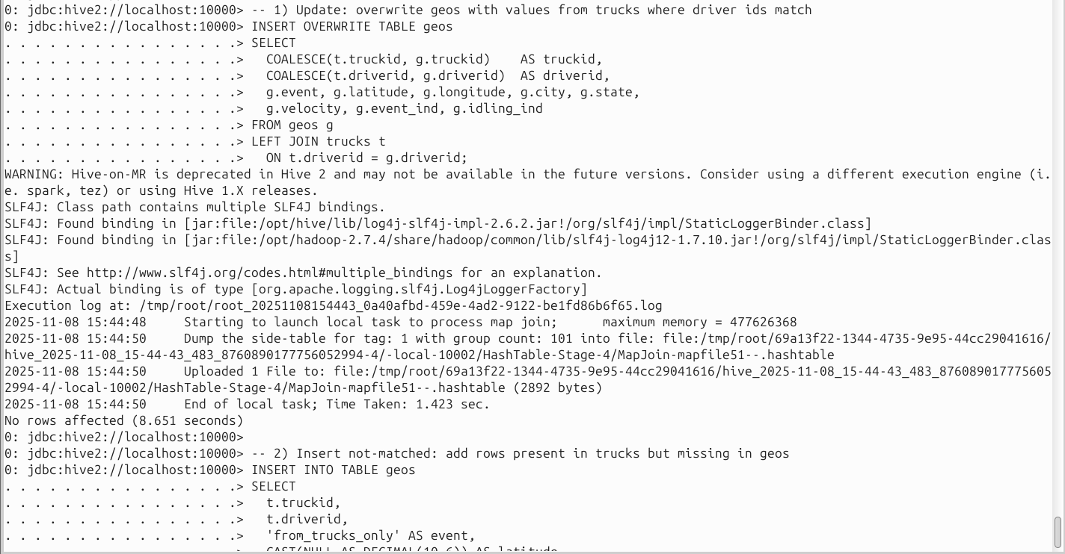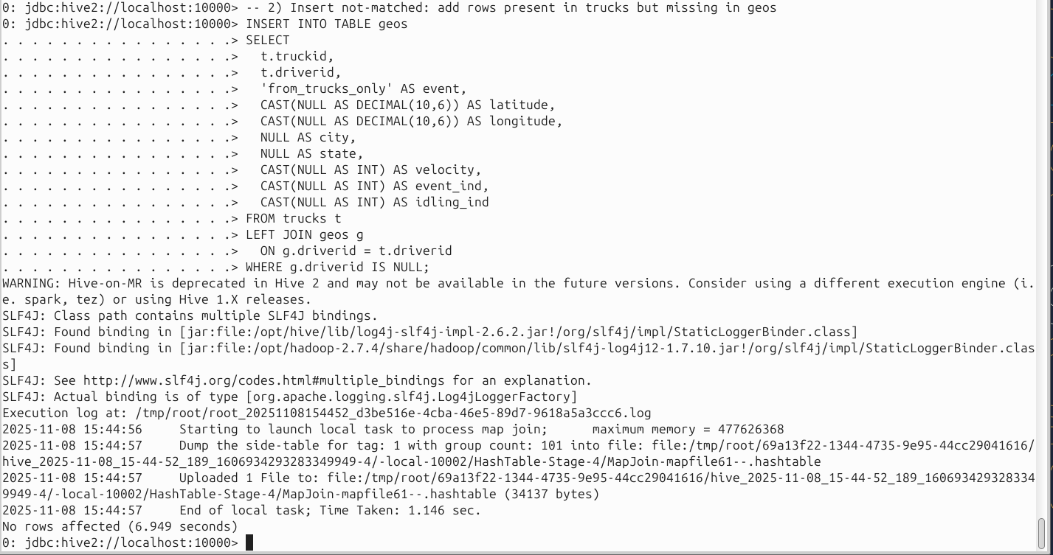

First part updates matching rows from trucks; second part inserts new rows for drivers that exist only in trucks.  
• Joins:

o select geos.driverid,trucks.model,geos.city from geos join trucks where   
geos.driverid=trucks.driverid;

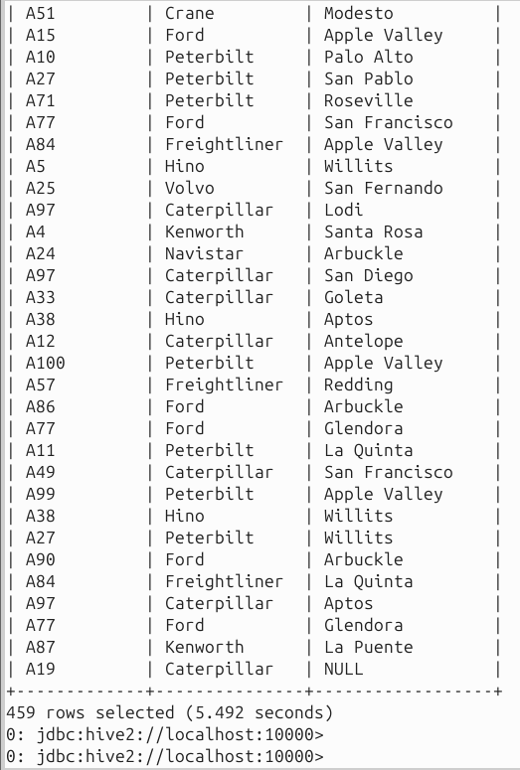

Returns only drivers present in both geos and trucks (inner join).  
o select geos.driverid,trucks.model,geos.city from geos left outer join trucks   
where geos.driverid=trucks.driverid;

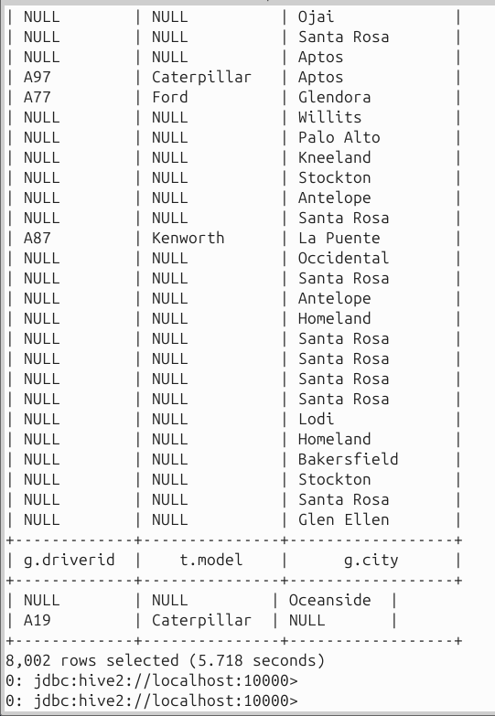

Returns all geos rows and matches model when a trucks row exists (left keeps all left).  
o select geos.driverid,trucks.model, geos.city from geos right outer join trucks   
where geos.driverid=trucks.driverid;

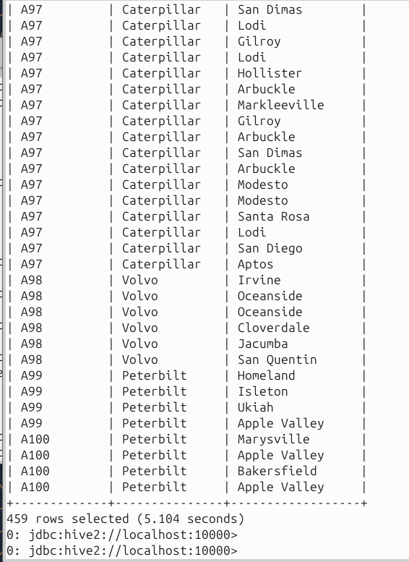

Returns all trucks rows and merges geos info when present (right keeps all right).  
o select geos.driverid,trucks.model, geos.city from geos full outer join trucks   
where geos.driverid=trucks.driverid;

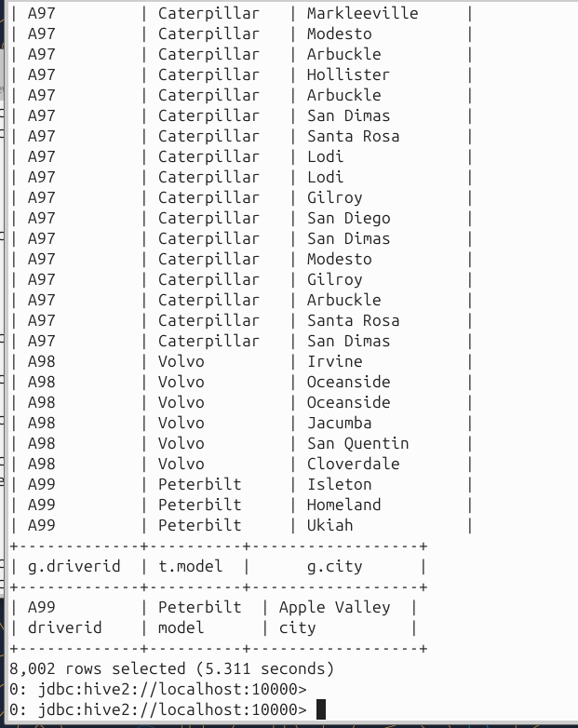

Returns rows from either table even when the other side is missing (complete union of both).  
• [ToDo: Write queries for the following] :   
o Display truckid, driverid and model for every abnormal event

-- Display truckid, driverid and model for every abnormal event

SELECT g.truckid, g.driverid, t.model

FROM geos g

JOIN trucks t

ON t.driverid = g.driverid

WHERE g.event_ind = 1; -- abnormal = flagged rows (works even if event text varies)

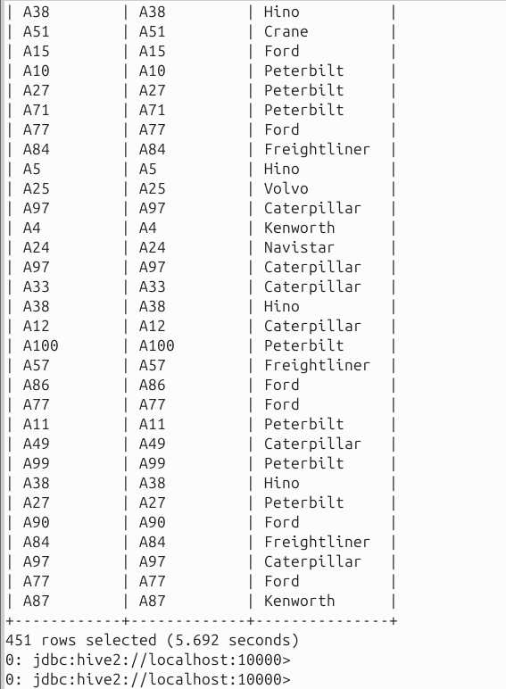  
Shows truck/model only for rows that are flagged abnormal via event_ind=1.

o Display truckid, driverid, model and city for velocity > 25.

-- Display truckid, driverid, model and city for velocity > 25

SELECT g.truckid, g.driverid, t.model, g.city

FROM geos g

JOIN trucks t

ON t.driverid = g.driverid

WHERE g.velocity > 25;

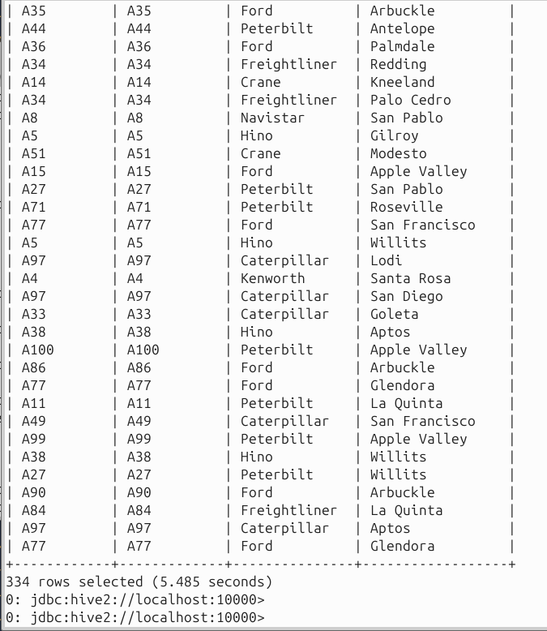

Lists faster-moving trucks with their model and the city where that reading occurred.  
o Display complete record of the trucks for events where they were on unsafe   
following distance.

-- Display complete record of the trucks for "unsafe following distance" events

-- (handle both exact text and variants)

SELECT t.*

FROM geos g

JOIN trucks t

ON t.driverid = g.driverid

WHERE LOWER(g.event) = 'unsafe_follow_distance'

OR LOWER(g.event) LIKE '%unsafe%follow%distance%';

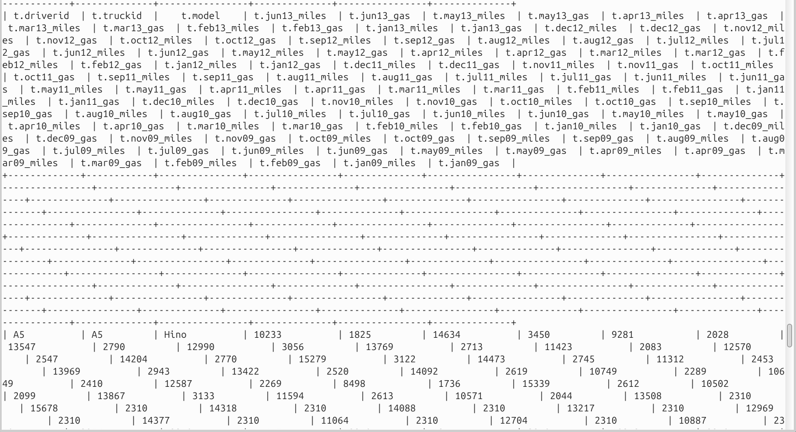

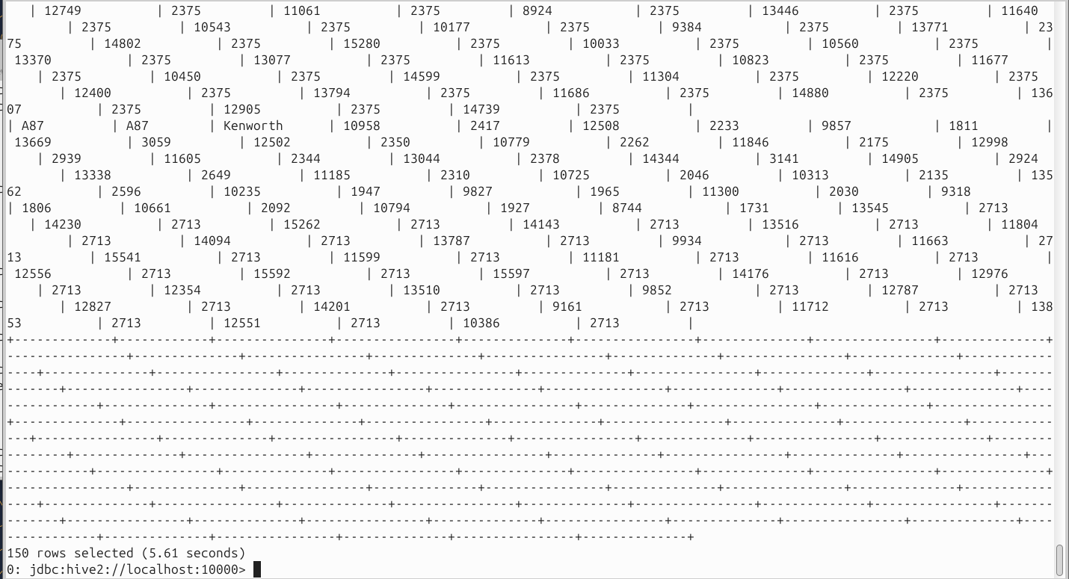  
Pulls the full trucks row for any geos record whose event indicates unsafe following distance (handles naming variations).

# Hive Transaction Manager:

One of the important properties that you need to know is hive.txn.manager which is used to   
set Hive Transaction manager, by default hive uses DummyTxnManager, to enable ACID, we   
need to set it to DbTxnManager.   
SET hive.support.concurrency=true;

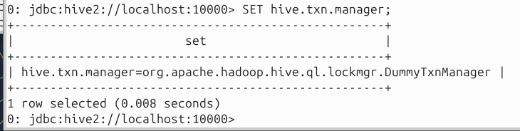  
SET hive.txn.manager=org.apache.hadoop.hive.ql.lockmgr.DbTxnManager;   
   
# The following are not required if you are using Hive 2.0   
SET hive.enforce.bucketing=true;   
SET hive.exec.dynamic.partition.mode=nostrict;   
   
# The following parameters are required for standalone hive metastore:   
SET hive.compactor.initiator.on=true;   
SET hive.compactor.worker.threads=1

[ToDo: execute several hive commands from truck data and show the difference in   
performance between ACID and non -ACID transaction managers]   
Below are some of the limitations of using Hive ACID transactions:   
• To support ACID, Hive tables should be created with TRANSACTIONAL table property.   
Currently, Hive supports ACID transactions on tables that store ORC file format.   
• Enable ACID support by setting transaction manager to DbTxnManager   
• Transaction tables cannot be accessed from the non -ACID Transaction Manager   
(DummyTxnManager) session.   
• External tables cannot be created to support ACID since the changes on external   
tables are beyond Hive control.   
• LOAD is not supported on ACID transactional Tables. hence use INSERT INTO.   
• On Transactional session, all operations are auto commit as BEGIN, COMMIT and   
ROLLBACK are not yet supported.

NEW HIVE, create database as it doesnt exist

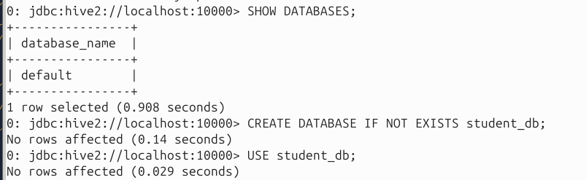

Created table as it doesnt exist

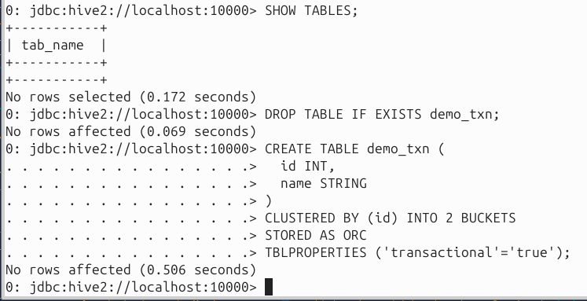

Inserted data



Updated data (it worked!)

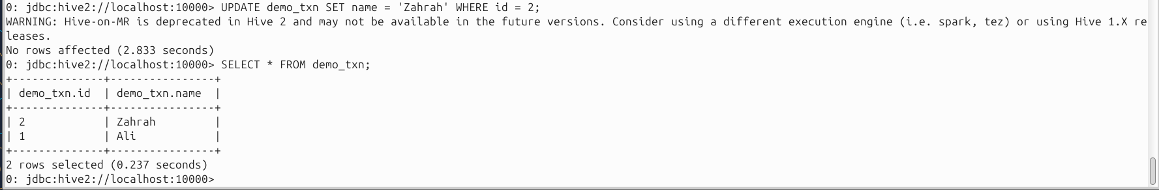

Deleted data (it worked!)

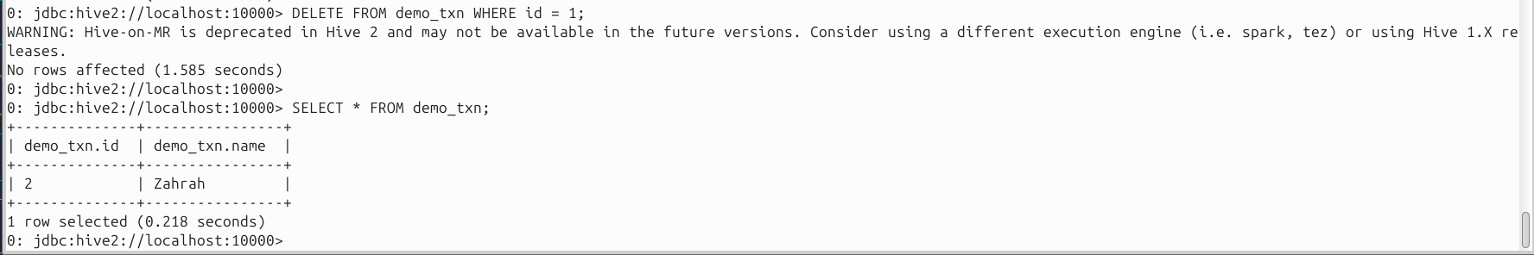

Loaded geos data

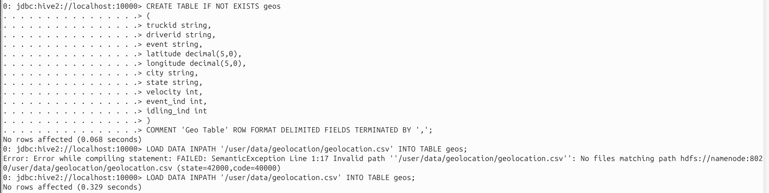

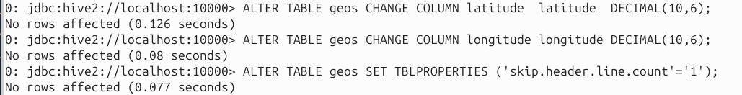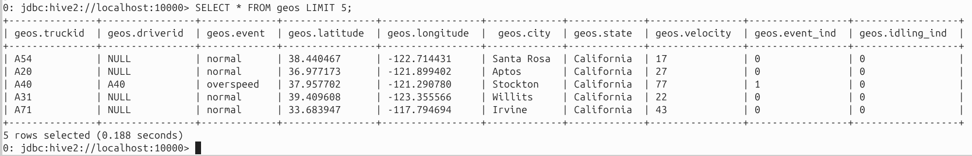

Loaded trucks data

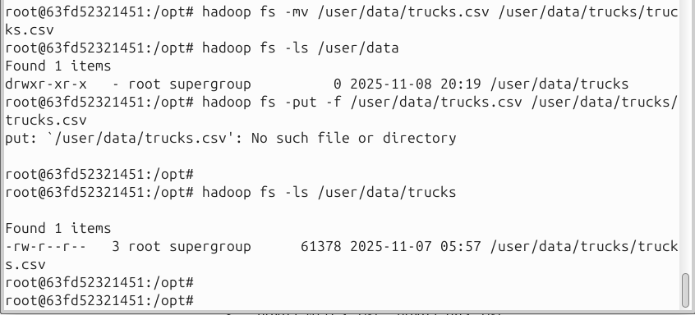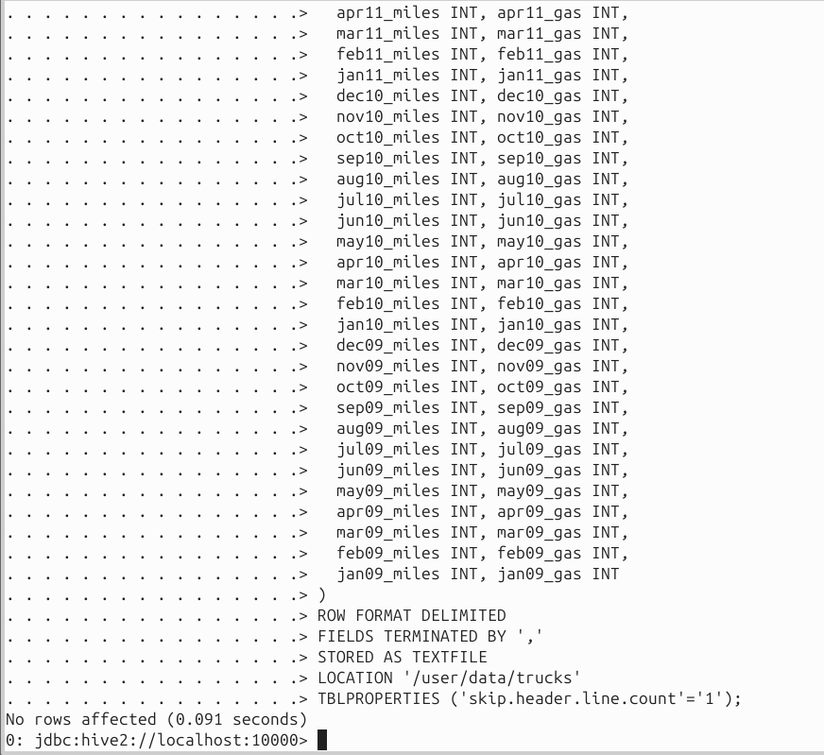

Make geos table transactional

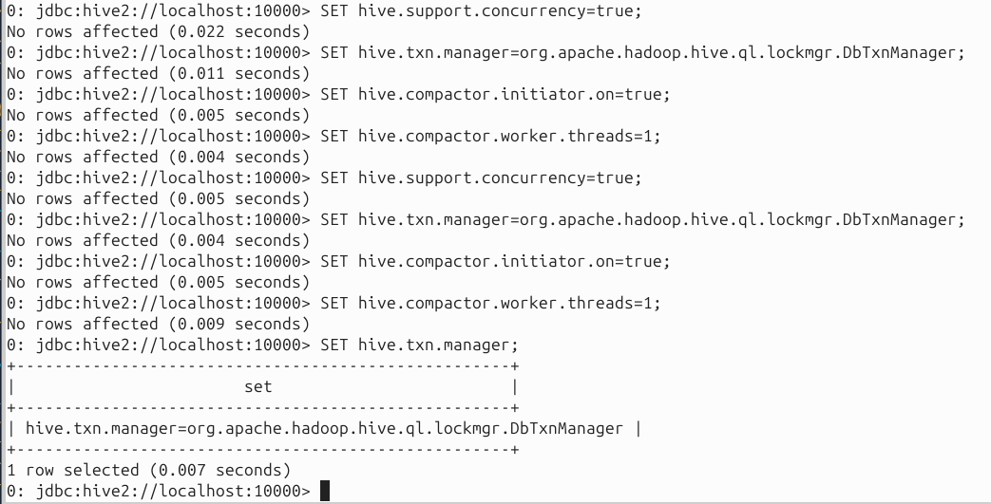

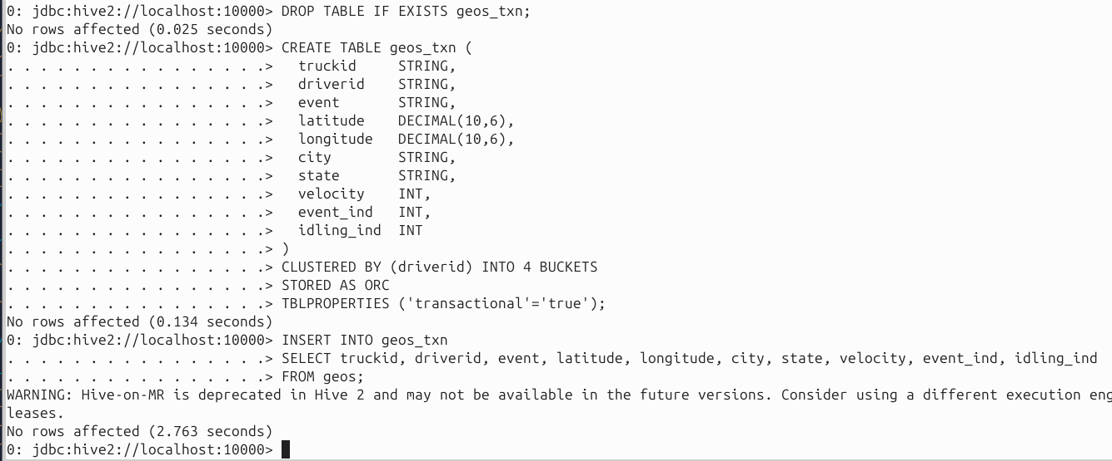



Regular HIVE SELECT TIME

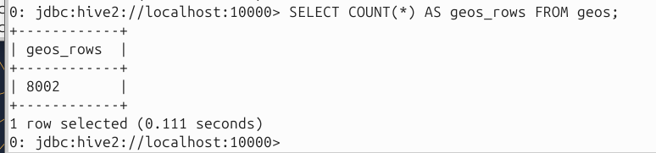

UPDATED HIVE SELECT TIME

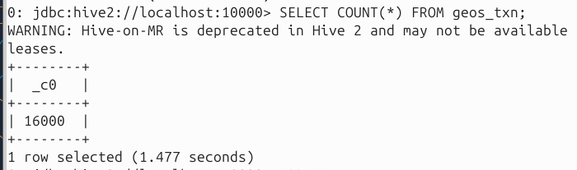

REGULAR HIVE EXPLAIN TIME

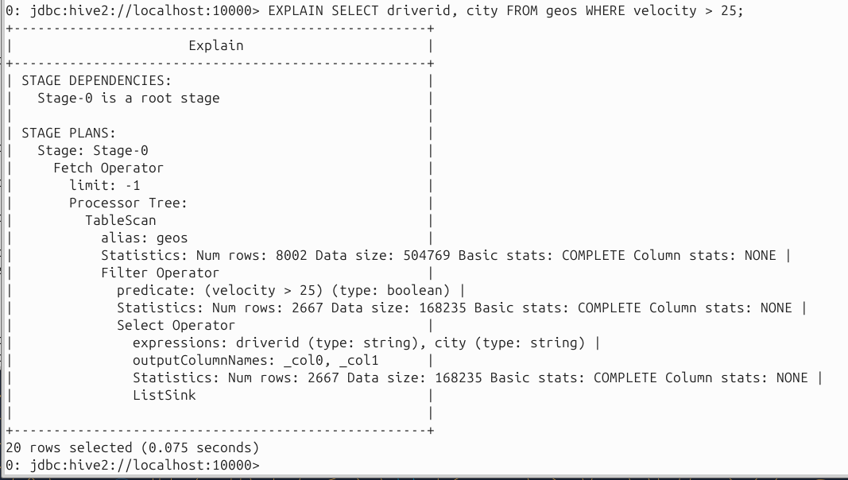  
 UPDATED HIVE EXPLAIN TIME

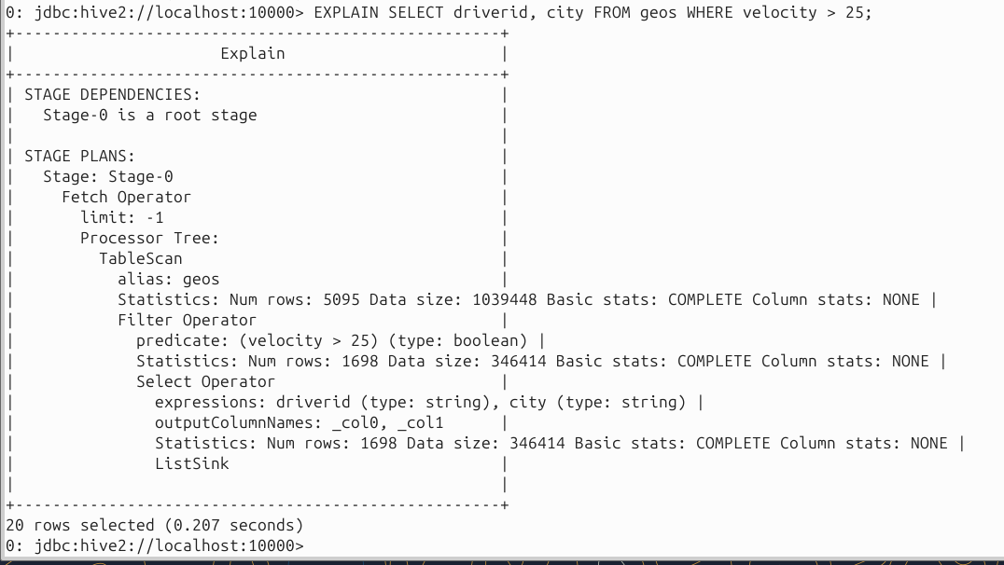

REGULAR HIVE UPDATE FAILED



UPDATED HIVE UPDATE WORKED

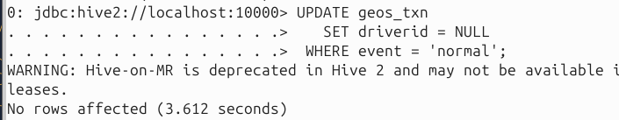

# Bonus Question (1% ):

Experiment with Tez, Spark and LLAP execution engines and benchmark wrt MR.

**TEZ**

Setup tez

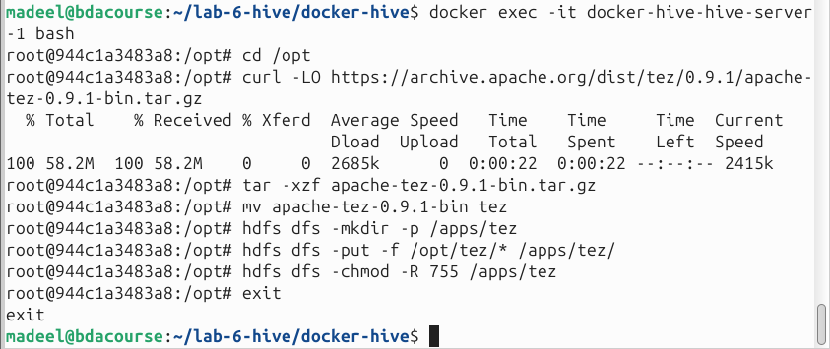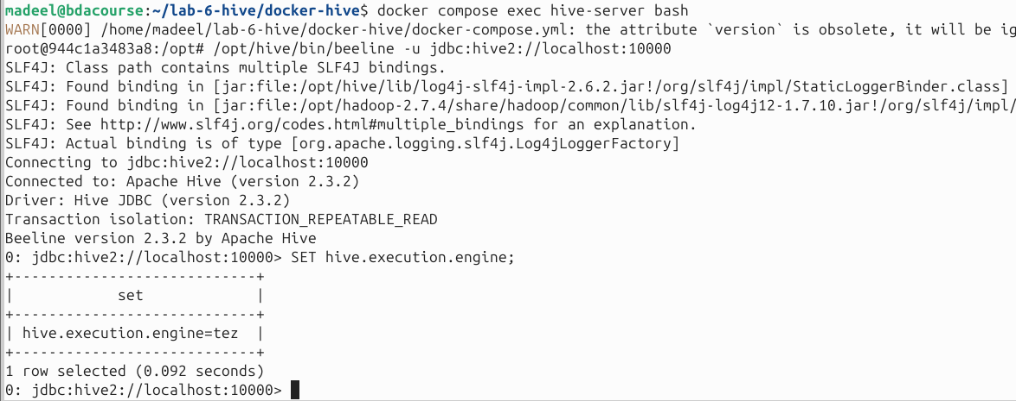

Created dataset

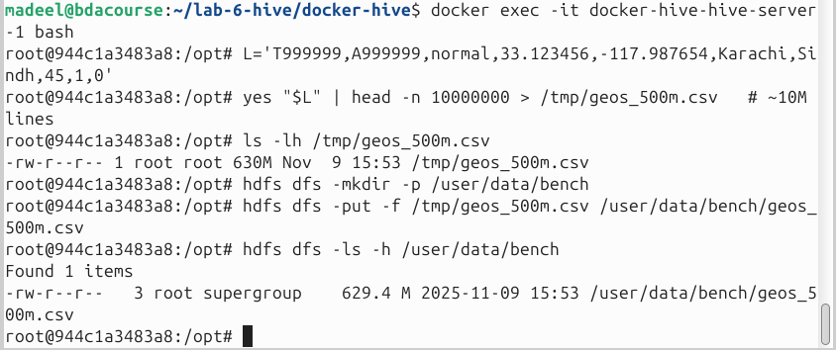

Created extrernal database on hive that loads this dataset

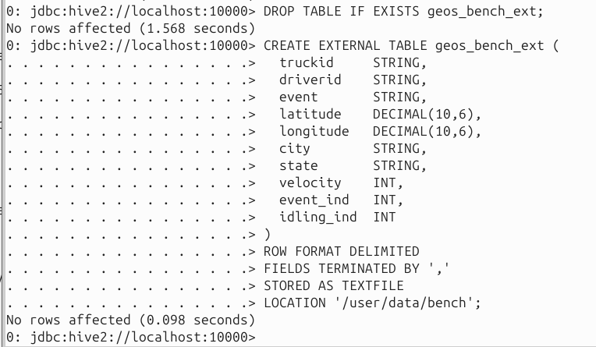

Created transactional database to load

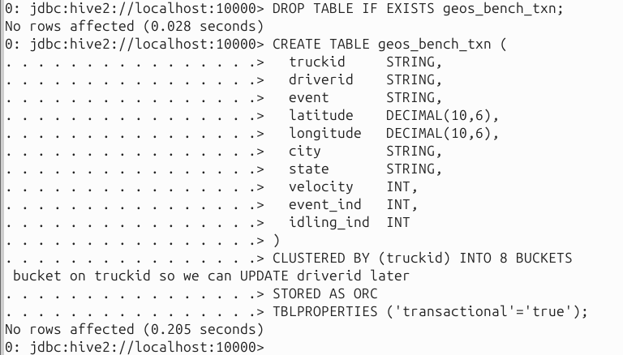

Then set Tez

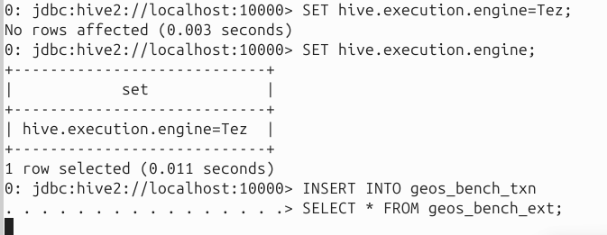

Now loading the data into transactional database

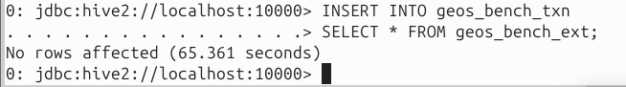

Completed.

TEZ SELECT TIME

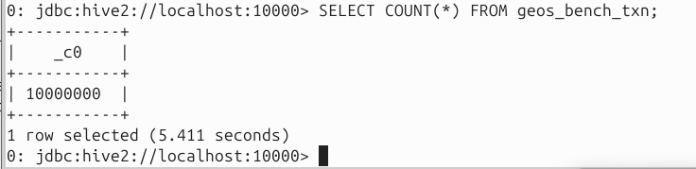

TEZ EXPLAIN TIME

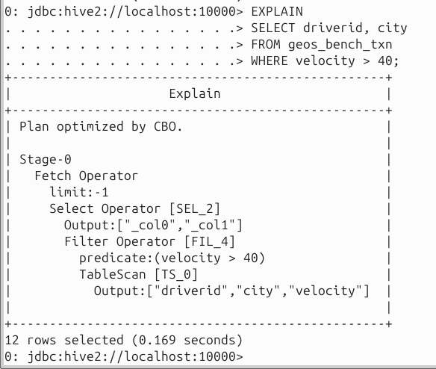

TEZ UPDATE TIME

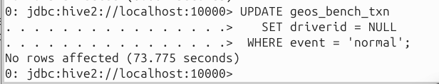

TEZ DELETE TIME

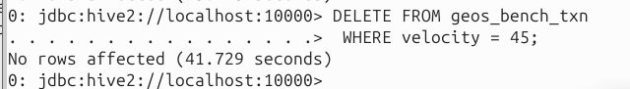

**SPARK**

Downloading spark from github repo

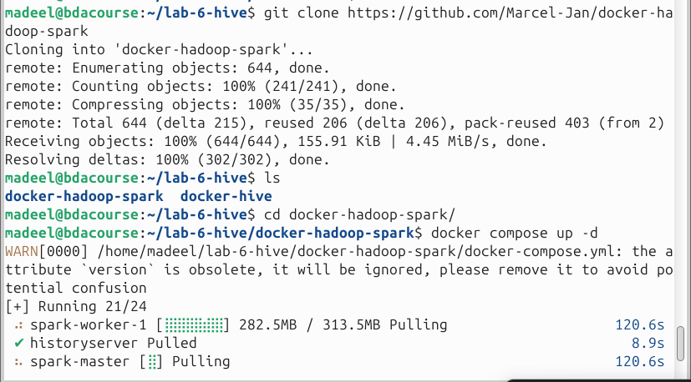

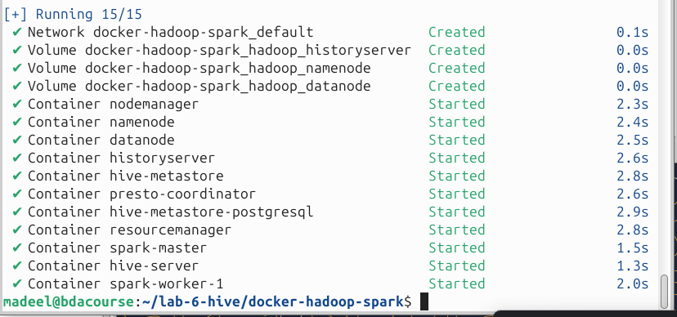

Created data, created databases and then inserted data in the databases.

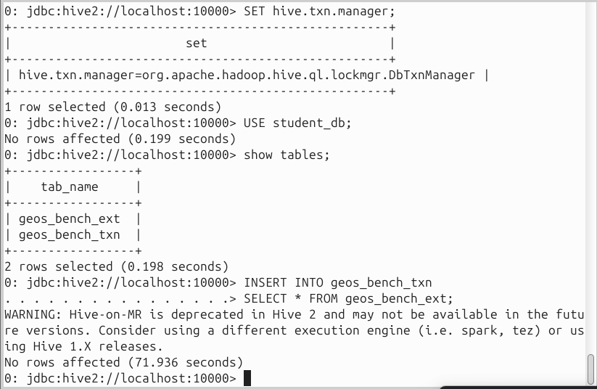

SELECT TIME

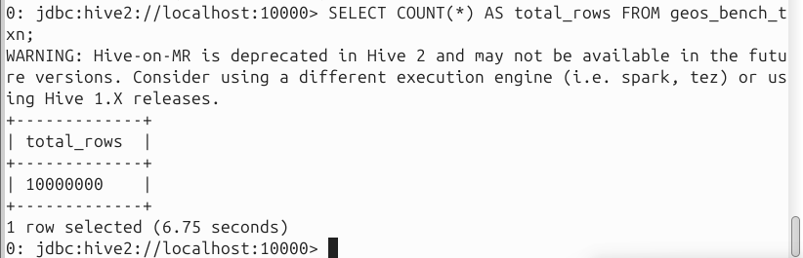

EXPLAIN TIME

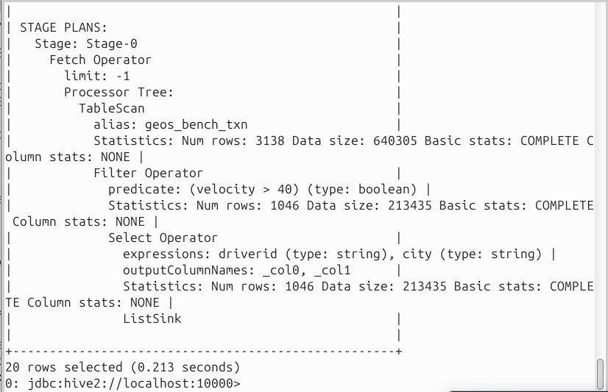

UPDATE

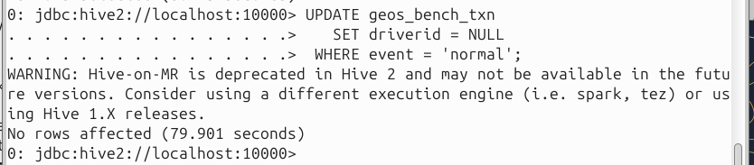

DELETE

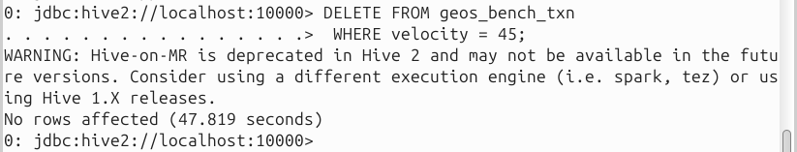

MR

Created dataset and tables. Now doing SELECT

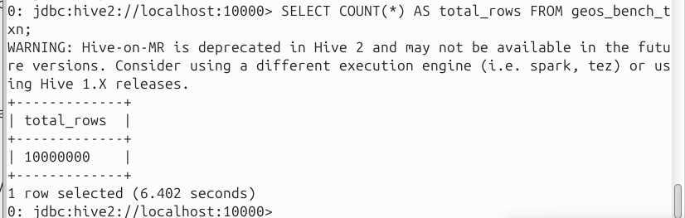

EXPLAIN

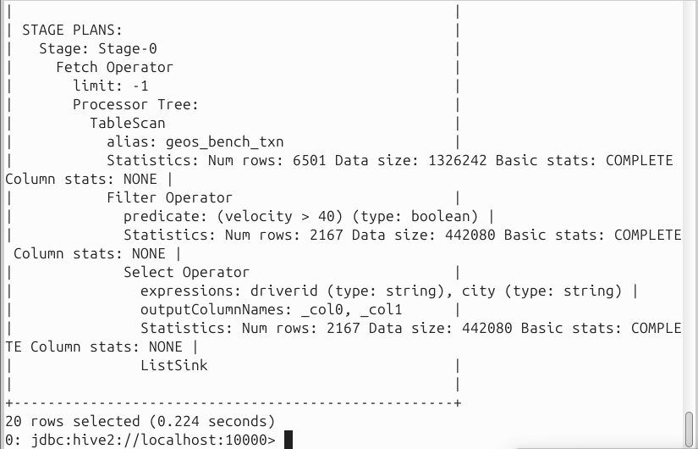

UPDATE

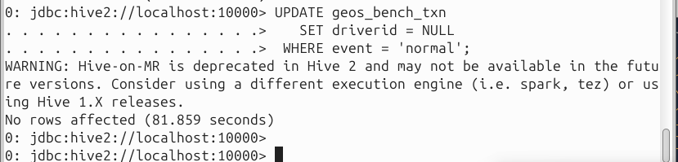

DELETE

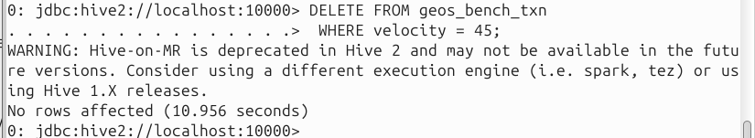

LLAP

Created dataset, database and was setting the values

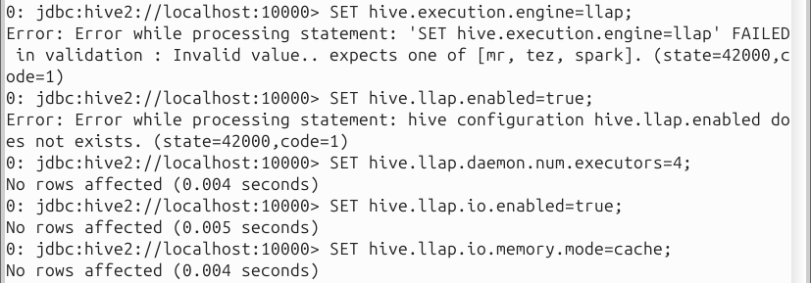

It is not working as it requires hive version 3. We have hive version 2. Could not find any setup/compose file for hive version3 to support llap.

**COMPARISION TABLE**

| seconds | MR | TEZ | SPARK |
| --- | --- | --- | --- |
| **SELECT**  SELECT COUNT(*) AS total_rows FROM geos_bench_txn; | 6.402 | 5.411 | 6.75 |
| **EXPLAIN**  EXPLAIN  SELECT driverid, city  FROM geos_bench_txn  WHERE velocity > 40; | 0.224 | 0.169 | 0.213 |
| **UPDATE**  UPDATE geos_bench_txn  SET driverid = NULL  WHERE event = 'normal'; | 81.859 | 73.775 | 79.901 |
| **DELETE**  DELETE FROM geos_bench_txn  WHERE velocity = 45; | 10.956 | 41.729 | 47.819 |

DATASET CREATION

# 2) Generate ~550–600 MB CSV quickly (10M identical rows; safe >500MB)

L='T999999,A999999,normal,33.123456,-117.987654,Karachi,Sindh,45,1,0'

yes "$L" | head -n 10000000 > /tmp/geos_500m.csv # ~10M lines

# 3) Verify size (should be ~500–650MB depending on newline)

ls -lh /tmp/geos_500m.csv

# 4) Put into HDFS under a dedicated folder

hdfs dfs -mkdir -p /user/data/bench

hdfs dfs -put -f /tmp/geos_500m.csv /user/data/bench/geos_500m.csv

hdfs dfs -ls -h /user/data/bench